Social Housing Heat Pump Strategic Review template

Version 0.1
Date: 25 March 2026

Disclaimer
This document has been produced by Bristol City Council who take no liability for it’s use. The purpose of the document is to provide a template that social housing providers might use to coordinate the review of activities within their organisations around heat pumps. This is essential to better coordinate organisational activities and deliver quality outcomes.

Table of Contents:
Disclaimer 1
Table of Contents: 1
1. Background 3
2. Complementary projects 3
3. Approach to review 4
3.1 Stages of each cycle review: 4
3.2 Focus areas for cycles: 4
4. Overall scope of review 5
4.1.1 People 6
4.1.2 Policies & Process 6
4.1.3 Organisation 6
4.1.4 Governance 7
4.1.5 Operations 7
5. Areas of focus 7
5.1 Prioritisation approach 8
5.2 Summary of focus areas actions, outputs and outcomes 8
5.2.1 Procurement 8
5.2.2 Planning Permission 9
5.2.3 Specifications/ Employer requirements (including technology choices) 9
5.3.4 Installation 10
5.3.5 Handover 10
5.3.6 Quality assurance/ monitoring 11
5.3.7 Data Management Systems/ Existing stock review 12
5.3.8 Training/ Learning 12
5.3.9 Service and maintenance arrangements 13
5.3.10 Technology options 13
5.3.11 Non-Domestic 14
6. Stakeholder engagement 14
7. Timeline 15
8. Project sponsors 15
9. Task Group 15

1. Background
The review is coordinated by X in collaboration with X It has been agreed to provide a structured assessment of how heat pumps are specified, commissioned, monitored, and managed across the social housing portfolio, and to identify the changes required to support effective large-scale deployment.
This document outlines what should be included in the project plan by considering which aspects of our work are most essential to review. A full project plan will be developed at the project initiation stage based on feedback from key stakeholders, including asset management, housing operations, repairs and maintenance, sustainability teams, contractors, and residents where appropriate.
The review is needed due to the increasing rollout of heat pumps through decarbonisation programmes and funding schemes. Local project experience and internal audits have highlighted variability in system performance, commissioning quality, resident experience, and clarity of responsibilities across delivery partners. These challenges include inconsistent design assumptions, limited post-installation optimisation, unclear ownership of performance monitoring, and gaps in resident support.
This reflects wider national experience. Programmes such as ECO4 have accelerated heat pump installations but also exposed issues including inconsistent commissioning, limited performance verification, and fragmented accountability between installers, manufacturers, and housing providers. These challenges highlight the need for clearer governance, defined operational processes, and proactive performance monitoring.
This strategic review will examine current arrangements across People, Policies & Process, Organisation, Governance, and Operations to identify gaps and define a future operating model for heat pump delivery and management, supporting consistent deployment and improved resident outcomes.

2. Complementary projects
List relevant projects relating to heat pumps...
These completed projects have provided input to, and informed the development of, this strategic review, ensuring it reflects recent learning and emerging good practice.

3. Approach to review
To achieve the greatest impact the review will need to follow stages from definition through to deployment. It is suggested so that there is a prioritisation of the focus areas. This will be followed by a staged review process. This document represents the Definition phase, as shown in Figure 1 .

3.1 Stages of each cycle review:
The stages of the review process are shown in Figure 1:
Figure 1. Stages of review process.
1. Define
2. Discover
3. Design
4. Deploy

Discover: Gathering data and defining what the future needs to look like
Design: Designing the change strategy by assessing the impact
Deploy: Engaging stakeholders to test and deploy solutions for BAU

3.2 Focus areas for cycles:
To keep the review achievable, it is recommended that a specific priority topic is chosen and worked on one at a time, as shown in Figure 2. Once the priority areas are chosen, each one is looked at separately while still keeping in mind how they connect to each other.
This could operate on 6 week sprint cycles or a timescale proportionate to the scale of the review area (see Figure 2). Critical to this approach would be to identify and implement quick wins to deploy immediately alongside medium and longer term recommended actions.
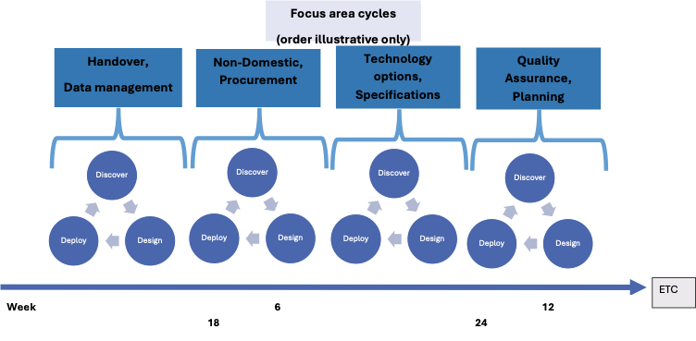
Figure 2: Review sprints per priority area.

4. Overall scope of review
The review comprises five dimensions: People, Policies & Process, Organisation, Governance, and Operations, as shown in Figure 3. A comprehensive review should assess each of these areas systematically to understand readiness, barriers, and required changes for scaling and managing heat pumps.
Each diremption of the review presented in Figure 3 is detailed below:
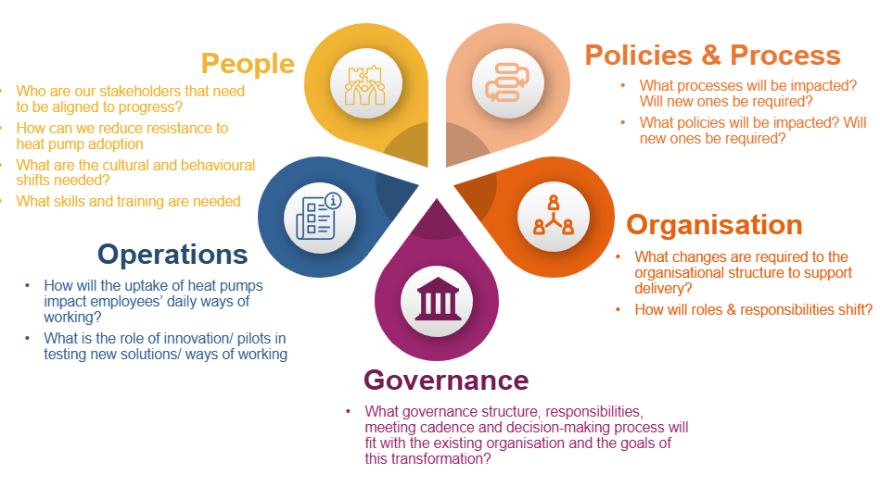

Figure 3: The five dimensions of the review.

4.1.1 People
Heat pumps change how homes are heated, how systems are commissioned, and how performance is managed. This means staff, contractors, and residents must adopt new behaviours, skills, and expectations. Without addressing people-related factors, even well-designed systems can underperform due to incorrect use, resistance, or lack of confidence.
The review should consider:
- Who are our stakeholders that need to be aligned to progress?
- How can we reduce resistance to heat pump adoption?
- What cultural and behavioural shifts are needed?
- What skills and training are required?
- What support do tenants and frontline staff need?

4.1.2 Policies & Process
Heat pumps require different commissioning, monitoring, and maintenance processes compared to traditional heating systems. Existing policies may not cover performance verification, remote monitoring, or shared responsibility between organisations. Reviewing policies and processes ensures consistent delivery and clear expectations across projects.
The review should consider:
- What processes will be impacted?
- Will new commissioning and monitoring processes be required?
- What policies need updating or creating?
- How will performance be measured and signed off?
- How will issues be identified and escalated?

4.1.3 Organisation
Delivering and managing heat pumps often cuts across multiple teams including assets, repairs, sustainability, housing management, and contractors. Organisational structures designed for reactive gas maintenance may not support proactive performance management. Reviewing organisational arrangements ensures responsibilities are clear and resources are in place.
The review should consider:
- What organisational changes are required to support delivery?
- How will roles and responsibilities shift?
- Are new roles required (e.g., performance monitoring)?
- Where will monitoring and commissioning sit?
- How will teams coordinate across functions?

4.1.4 Governance
Heat pump performance depends on ongoing oversight, clear accountability, and timely decision-making. Without governance structures, issues such as underperformance, tenant discomfort, or unclear ownership can persist. Governance ensures strategic alignment and operational accountability.
The review should consider:
- What governance structure is needed?
- Who is responsible for performance after installation?
- How will decisions be made and tracked?
- What meeting cadence is required?
- How will performance data inform decisions?

4.1.5 Operations
Heat pumps change day-to-day operational activities, including commissioning, maintenance, and fault diagnosis. Moving from reactive repairs to proactive monitoring requires new workflows and tools. Reviewing operations ensures teams can effectively manage systems once installed.
The review should consider:
- How will heat pump uptake impact daily ways of working?
- How will remote monitoring be used operationally?
- What is the role of pilots and innovation?
- How will faults be identified and resolved?
- How will systems be optimised over time?

5. Areas of focus
Below we list a range of focus areas the review could take. These will need to be prioritised and resourced within this project budget accordingly.
Focus Area installation journey: | Relevant housing type (scope TBC) and current status re work to date  (Red: no work undertaken or not recently updated/reviewed, Amber: work underway/ refresher may be required, Green: Complete and/or substantive work commenced) |  |  |  |  | Priority  TBC
Focus Area installation journey: | New build | Social Retrofit | Non Domestic | Re-fits | Local Grant retrofit
Procurement
Planning department
Specifications/ Employer requirements
Installation
Handover
Quality assurance/ monitoring
Service and maintenance arrangements
Other
Technology options
Data Management Systems/ Existing stock review
Training/ learning
Non-domestic

5.1 Prioritisation approach
A prioritisation approach will be agreed with the project task group and ultimately by the project sponsors. Variables that could be factored in to the prioritisation matrix include:
- Urgency
- Risk to business
- Impact
- Capacity of consultees to support and implement
- Quick wins

5.2 Summary of focus areas actions, outputs and outcomes

5.2.1 Procurement
State why procurement practices need review

Procurement Review  Actions: | Outputs | Outcomes
- Assess current tender specification for heat pumps |  | Higher quality installations

5.2.2 Planning Permission
(for local authorities only)….For heat pumps installed outside of our own social housing or grant programme, the planning process might be our only wider point of contact with installations. Nonetheless this is still an important area if we are to be able to influence wider city uptake of low carbon heating.
Planning review  Actions: | Outputs | Outcomes
- Workshop with planning officers to establish current practice and good practice from elsewhere | Collate relevant documents. | Increased knowledge of heat pumps amongst planning team
- Recommendations of where the planning process can influence the quality of outcomes for heat pump installs (sustainability statements, noise, heritage, discharge process) | Recommendation report/ presentation to planning team | Improved planning processes around heat pumps

5.2.3 Specifications/ Employer requirements (including technology choices)
Specifications are critical to ensuring a successful heat pump installation.
Specifications/ Employer requirements  Actions: | Outputs | Outcomes
- Review specification for domestic and non-domestic installations | Recommendations for non-domestic specification | Improved specification for non-domestic installs
- Review employer requirements on new builds | Recommendations for new build employer requirements | Improved employer requirements
- Review specifications for GSHP/ other heat pump technologies. Consult and create where necessary | Specification creation for GSHP/ air to air heat pumps | New ASHP/ air to air heat pump specifications

5.3.4 Installation
Detail who currently installs, contractors or in house

Installation  Actions: | Outputs | Outcomes
- Review approach to installations in house or external

5.3.5 Handover
Resident handover is a critical step in ensuring a good experience of heat pumps for residents. Detail current handover materials available
Handover  Actions: | Outputs | Outcomes
- Collate and review existing handover documents | Folder with existing handovers collated | Better understanding of current handover practices
- Create standard handover for ASHP/ GSHP | New handover created | Better handover process for tenants

5.3.6 Quality assurance/ monitoring
Given challenges of finding competent installers, quality assurance at each stage of a heat pump journey is vital. Figure 4 below presents an example of quality assurance processes that needs to be replicated for other delivery avenues.
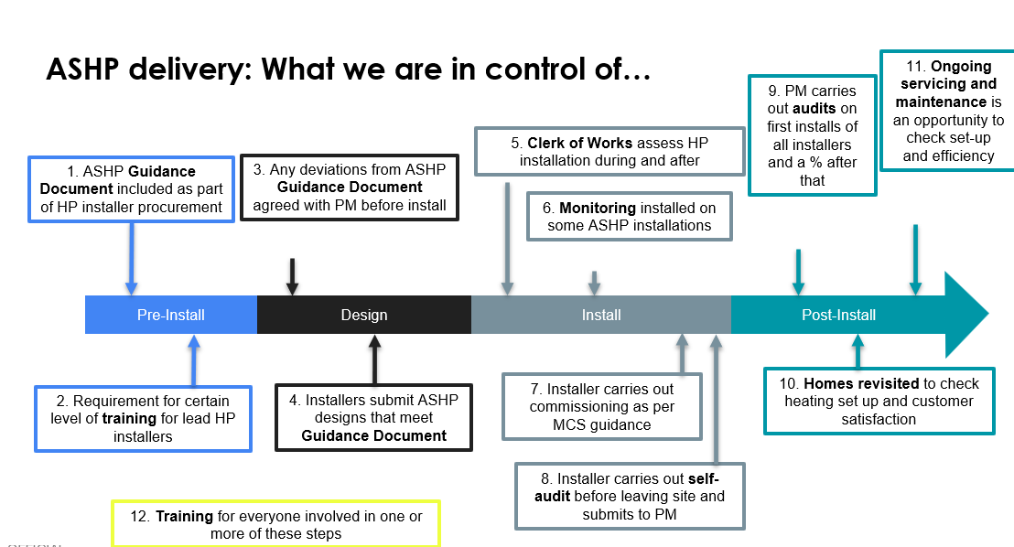
Figure 4: Stages of a heat pump journey example (Warms Homes grant delivery example).

Quality Assurance  Actions: | Outputs | Outcomes
- Review remote monitoring possibilities for existing and new stock
- Map the quality assurance journeys for non-domestic, new build and refits | Quality assurance process maps | Enhanced quality assurance processes across installations
- Review options for tools to enhance quality assurance e.g. heat pump design tools (Spruce, Carno etc) | Recommendations for use of new tools | Better tools to help manage heat pump journeys

5.3.7 Data Management Systems/ Existing stock review
How we store information around heat pump installations is vital to enable
- Effective servicing schedules
- Timely issue resolution e.g. spare parts
- Oversight of warranty arrangements
- Capturing of commissioning settings
- Strategic financial planning
The review will assess data management systems and provide recommendations going forward.

Data management systems  Actions: | Outputs | Outcomes
- Assess data management systems across social housing heat pump stock and non-domestic buildings | Collation of what is held where. | Better understanding of data management systems and gaps to be plugged
- Assess existing stock data including warranty arrangements, likelihood of needing audit, | Recommendation document highlight properties to be audited/ assessed | Financial savings from data and audit leading to capturing faults before warranty periods expire.
- Review existing replacement cost estimates for existing stock | Costs of replacement units updated | More accurate data on replacement costs
- Review existing data on costs per install by house typology | Cost data for installs collated | Better understanding of current installation costs

5.3.8 Training/ Learning
It is essential that we are ‘intelligent clients’ of delivering heat pump projects. Both for non-technical and technical maintenance staff knowing what ‘good’ looks like in imperative to quality delivery.
Detail any work undertaken in this area to date
Training/ Learning  Actions: | Outputs | Outcomes
- Design and deliver heat pump training for staff | Non-technical/ technical staff training courses | Staff trained in delivering heat pump projects

5.3.9 Service and maintenance arrangements
Heat pumps are required to be serviced annually to keep their warranties and also to ensure effective operation. Detail current maintenance regime.

Service/ maintenance arrangements  Actions: | Outputs | Outcomes
- Review service schedule and content | Comparison of actual vs needed maintenance | Equipment lasts longer and works better for tenants
- Review potential for low time high impact additional works to take place during service e.g. recommissioning | Additional works list and timings | Heat pumps last longer and perform better

5.3.10 Technology options
Detail existing approach to selecting low carbon heating option at properties
Technology options  Actions: | Outputs | Outcomes
- Review process for deciding on technology type in new build and retrofit including heat pumps, hot water delivery options and distribution systems | Summary of current methodology | Better understanding of current decision making approach
- Convene a workshop to discuss and decide a process for selecting technology types | Hierarchy of technology type options | Decision made around hierarchy of technology options

5.3.11 Non-Domestic
Detail approach to non-domestic heat pump installations

Non-domestic  Actions: | Outputs | Outcomes
- Review of installs to date and asset management around these. Potentially including arrangement of audits. | Quantification of installs on estate and key information | Better understanding of assets
- Implement QA processes on new builds | QA processes applied to newest installs | QA processes enhanced for new installations

6. Stakeholder engagement
The proposed approach to deliver the review will be to undertake the review in stages by focus area. It may be that there is an overlap between these and of course there are several interdependencies. The order of review will be decided in a first working group containing representatives from each of those areas to ensure this aligns with urgency and capacity of staff to engage with the process. It is suggested that New Builds and Non-domestic might be an urgent area of initial focus.
Approaches to the review will include:
- Setting up task group: key representatives from relevant departments to steer the project and priorities
- Data collection: gathering data/ gaining access from management systems or otherwise
- Interviews: 1:1 or group interviews with relevant colleagues
- Existing processes: gather and review existing process documents
- Shadowing: it may be beneficial to shadow colleagues to understand processes e.g. service visit
- Setting up/ Maintaining a Heat Pump Working Group: source of regular contact with departments and also discussion

7. Timeline
The strategic review process does not sit in isolation and for many of the focus areas identified where there is already ongoing work. An example approach to timeline for this is shown in Figure 5 below:

Figure 5. Timeline for review process.

8. Project sponsors
Detail who are the project sponsors and budget arrangements

9. Task Group
It is suggested that a task group is formed to help steer the project. This would include representatives from:
- List

